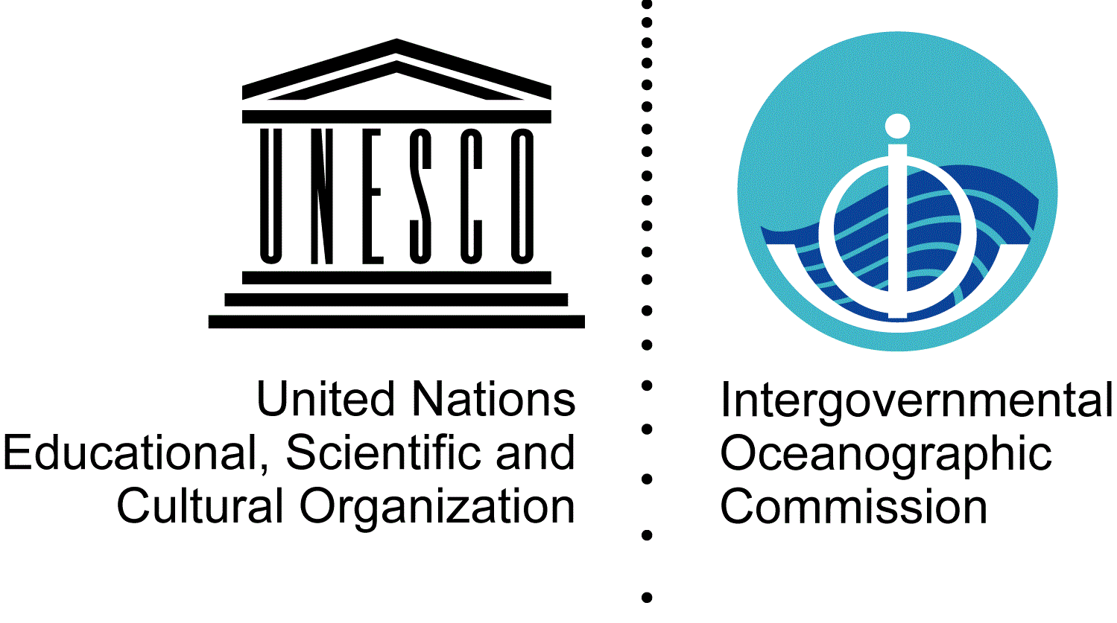

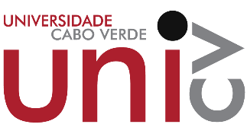 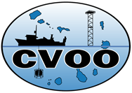 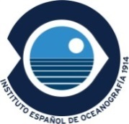 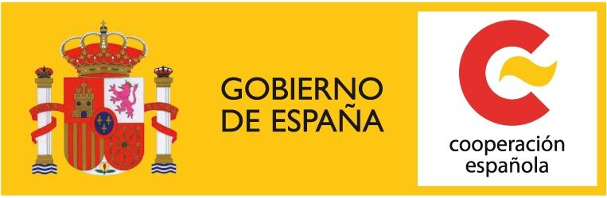

**WORKSHOP ON “Update of metadata, data availability and**

**application needs for a CCLME Eco-GIS viewer”**

Venue: Departamento de Ciência e Tecnologia of the University of Cabo Verde, Campus of Palmarejo. Avenida de Santo Antão - CP 279 C

ROOM

Praia – 03-05 November 2015

**AGENDA**

**Tuesday 3rd November 2015**

|  |  |
| --- | --- |
| TIME |  |
| 09:45-10:15 | Reception of participants at the Department of Science and Technology of the University of Cabo Verde, Campus of Palmarejo |
| 10:15-11:15 | Welcome:   * Mr. Mika Odido, IOC Coordinator in Africa, IOC-UNESCO Sub Commission for Africa and the Adjacent Island States, UNESCO Regional Office for Eastern Africa IOC-UNESCO * Mr. Antonio Leao de Aguiar Correia E Silva, Minister of High Education, Science and Innovation and President of the National commission for UNESCO * Ms. Sara Lopes, Minister of Maritime Infrastructure and Economy * Dr. Sonia Silva Vitória, Pro-Rector for Research of the University of Cabo Verde * Mr. or Ms. ....., Delegate in Cabo Verde of the Instituto Nacional de Desenvolvimento das Pescas * Mr. Jaime Puyoles García, General Coordinator of the Technical Cooperation in Cabo Verde, Spanish Agency for International Cooperation Development (AECID) * Dr. Luis Valdés, Instituto Español de Oceanografía (Spain) * Ms. Ulrika Richardson, Resident coordinator of the UN |
| 11:15-11:45 | Coffee break |
| 11:45-12:15 | *Presentation of the participants & Workshop agenda/organization*  Mr. Luis Valdés, IEO (Spain) |
| 12:15-12:30 | *Presentation of the project and the IOC Technical Series publications 110 and 115*  Ms. Itahisa Déniz González, IOC-UNESCO; and Mr. Luis Valdés, IEO (Spain) |
| 12:30-13:00 | *Presentation of the Prototype of the CCLME Eco-GIS Viewer and prospects of needs for applications* – Mr. Luis Miguel Agudo, IOC-UNESCO |
| 13:00-14:30 | Lunch break |
| 14:30-16:30 | * *Current state of geoprocessing development on the web applications: NODE.js, R in the server , ArcGIS server and Geo-server –* Mr*.* Luis Miguel Agudo, IOC-UNESCO * *Open data platform and knowledge sharing* – Mr. Nuno Coelho, ESRI Portugal in Cabo Verde (Cabo Verde) * *Visualization tool on Ecosystem services, the TWAP and some technology options for developing decision support tools* – Ms. Ana Barbosa, IOC-UNESCO |
| 16:30-17:00 | Coffee break |
| 17:00-17:30 | * *FAO role and experiences in spatial data analysis supporting fisheries management* – Mr. Fabio Carocci, FAO (Italy) |
| 17:30-18:00 | Discussion |

**Wednesday 4th November 2015**

|  |  |
| --- | --- |
| TIME |  |
| 9:00-11:00 | * *IEO spatial data infrastructure* – Ms. Olvido Tello, Instituto Español de Oceanografía (Spain) * *SHOM public platform for GIS data* – Ms. Nathalie Leidinger, Service hydrographique et océanographique de la Marine (France) * *ODINAFRICA, the Ocean Data and Information Network for Africa* – Mr. Mika Odido, IOC Coordinator in Africa, IOC-UNESCO Sub Commission for Africa and the Adjacent Island States, UNESCO Regional Office for Eastern Africa |
| 11:00-11:30 | Coffee break |
| 11:30-13:00 | * *New GIS Thematics on a "Coral Mapping Project" in Cabo Verde*- Mr. Rui Freitas, Department of Engineering and Marine Science of the University of Cabo Verde (Cabo Verde) * *CCLME Coastal Marine Atlas* – Mr. Anis Diallo, Centre de Recherches Océanographiques de Dakar-Thiaroye (Senegal) |
| 13:00-14:30 | Lunch break |
| 14:30-15:30 | * *The Cape Verde Ocean Observatory: a multi-platform ocean time-series station* – Mr. Pericles Silva, Cabo Verde Ocean Observatory, INDP (Cabo Verde) * *Current state of the oceanographic data in Mauritania* – Mr. Bambaye Hamady, Institut Mauritanien des Recherches Océanographiques et des Pêches (Mauritanie). |
| 15:30-16:30 | Brain storming |
| 16:30-17:00 | Coffee break |
| 17:00-18:00 | Discussion |

**Thursday 5th November 2015**

|  |  |
| --- | --- |
| TIME |  |
| 09:00-09:30 | * *Joint Submission to the Commission on the Limits of the Continental Shelf in Respect of Areas in the Atlantic Ocean Adjacent to the Coasts of West Africa: The Republic of Cabo Verde; The Republic of The Gambia; The Republic of Guinea; The Republic of Guinea-Bissau; The Islamic Republic of Mauritania; The Republic of Senegal; The Republic of Sierra Leone* – Mr. António Pina and Ms. Sonia S. Victoria, Department of Science and Technology of the University of Cabo Verde |
| 9:30-10:30 | Other applications to be taken into account |
| 10:30-11:00 | Coffee break |
| 11:00-12:00 | Brain storming |
| 12:00-13:00 | Conclusions of the Workshop on Update of metadata, data availability and application needs for a CCLME Eco-GIS viewer |
| 13:00 | Closing of the Workshop on Update of metadata, data availability and application needs for a CCLME Eco-GIS viewer  Mr. Luis Valdés & Mr. Mika Odido |